**AKENTEN APPIAH-MENKA**

**UNIVERSITY OF SKILLS TRAING AND ENTREPRENEURIAL**

**DEVELOPMENT**

**FACULTY OF APPLIED SCIENCES AND MATHEMATICS EDUCATION**

**DEPARTMENT OF INFORMATION TECHNOLOGY EDUCATION**

**AUTOMATIC WATER TANK FILLING SYSTEM CONTROLLED USING ARDUINO BASED SENSOR FOR HOME APPLICATION FOR**

**(KUMASI METROPOLIS)**

BY

STEPHEN ASAMOAH-OKUBI 5191040169

ELIZABETH NKANSAH OKAI 5191040174

NIGMALIN BINTAGAN JOB 5191040185

QUAGRAINE GILBERT ESSUMAN 5191040175

OWUSU-ACHIAW ERIC 5191040142

# **CHAPTER ONE**

## **INTRODUCTION**

# **Introduction**

This chapter deals with the background of the project, statement of the problem which consist of the basis of the project, aim of the project and, research questions, justification of the project, significance of the project, scope of the project as well as the organization of the project report and chapter summary.

## **Background of the project**

Water is the most vital natural resource given by the divine in human’s daily life. Man need the water in almost every activity such as cleaning, drinking, cooking, washing, taking bath, the irrigation, and the industry needs. However, the level of healthy or clean water is decreasing, whereas the number of people in the world are always increasing. Considering to the need of water for each community in Ashanti region especially communities in Kumasi Metropolitan district and its county, it can be analysed that the clean water supply must be promoted in order to fulfil the people need of the clean water regularly.

Technology aids in cultural transformation (Layton, 1974). Technology is frequently created to assist individuals in performing certain tasks more easily. As a result, technological progress is frequently the catalyst for cultural change. Automation technology is one of the current technologies(Prima et al. 2017). In certain situations, people desire to have their job done automatically so that they may preserve energy for another activity. Specific advanced automation materials have been developed in order to automate some tasks, such as the Arduino microcontroller, which offers logical control of electrical circuits (D’Ausilio, 2012).

The Arduino board is intended to control the circuit logically. The fundamental component of Arduino is an integrated circuit chip that can be programmed using the C++ programming language. Atmel's AVR microcontroller is used in this application. The gadget can read the input, run the programme, and provide a variety of outputs based on our needs. As a result, the microcontroller is similar to the human brain. In earlier works, the Arduino based sensors have been used for the plant watering system(Devika, et al, 2014), the automated irrigation system(Nallani, et al, 2015), the soil humidity monitoring(Bitella, et al, 2014), the automated bottle filling system(Mashilkar, et al, 2015), the distance measurement, and the temperature control. We will suggest a unique use of an Arduino based sensor for autonomous water tank filling in this study. The Arduino microcontroller will be used to create a prototype of automated water tank filling. A water pump is a gadget used to pump groundwater into a water tank. Currently, different water pump models are in use. The initial model, the water pump, may be operated by manually turning on and off the equipment. The water pump on the other hand is fitted with a floating ball that acts as an actual tap when the water has filled a tank. However, certain flaws can be uncovered as a result of both approaches. The manually operated water pump is inefficient since it cannot switch on and off automatically. When someone forgets to switch off a pumping equipment, the circumstance might cause water to leak.

It will have a consequence on the wasteful electricity consumption, and it may also destroy the wall since it is damp, wet, and mossy. Similarly, we contend that the second type of floating ball tap-equipped water tank is more beneficial than the manual switch, but the floater occasionally causes tap and pipe leakages because the ball has not fully closed the tap frame and therefore the water pressure cannot be kept by the pipe. To address the issues raised by both models, we aim to offer a water pump outfitted with an ultrasonic sensor and an Arduino microprocessor to make an automated switch and manage the amount of tank water filling. The sensor will switch on the machine automatically when the water tank reaches a specified level, and it will turn off automatically when the tank is entirely filled.

While water production has increased, average per-capita daily water usage in Kumasi has decreased, owing to population expansion outpacing supply. According to Kuma et al. (2010), daily per capita water used in 1996 was 24.2 m3/year.

(0.066 m3/day or 66 litres/day) and contend that it should have been 0.094 m3/day or 94 litres/day in 2009. According to GWCL, current per capita daily water use varies based on socioeconomic position. Low-income inhabitants, for example, consume 0.025–0.035 m3/day, whereas middle-income residents use 0.060–0.075 m3/day, and upper-income individuals consume 0.080–0.085 m3/day.  
Residents use more than 0.120 m3/day. 9 Average water use varies based on the number of persons in each family and the location of each household. Kumasi’s water production clearly needs to increase to meet demand, as shown in Table 1

Table 1. Water Demand Forecast (m3/day) for Kumasi

|  |  |  |  |
| --- | --- | --- | --- |
| Year | Demand in Litres per day | Production in Litres per day | Coverage,  % |
| 1990 | 69,678,000 | 68,200,000 | 98% |
| 2010 | 242,735,348 | 122,727,273 | 51% |
| 2011 | 256,382,827 | 150,021,032 | 59% |
| 2012 | 270,797,618 | 177,297,600 | 65% |
| 2013 | 286,022,863 | 204,574,100 | 72% |
| 2014 | 302,104,126 | 231,818,182 | 77% |
| 2015 | 319,089,538 | 231,818,182 | 73% |

Source: GWCL/AVRL ((Maoulidi 2010).

Barekese's basin region has been subjected to strong human pressure in recent years, reducing dam production. Encroachment by private property developers, farming, and forestry, for example, have all contributed to high silt levels entering the dam, which has hampered recent efforts to boost Bakersfield's water supply((Maoulidi 2010). Encroachment has had no negative impact on Owabi output since the catchment region is the Owabi Forest Reserve, which is off-limits to human activities. However, Owabi barely generates one-sixth of the water that Barekese does.

Other issues impacting the GWCL's operations include leaks, unauthorized connections, and nonpayment of consumers' bills.

## **Problem Statement**

The problem of efficient water management is one of the major problems of modern times, so there is an utmost need to address this problem. The proper waste management system is a must for a society in general and for a better world as a whole. Based on the issues, the author will carry out activities for the creation of an automatic water level tank system for use at home or in business. This system will use ultrasonic sensors to regulate reservoir water filling automatically. This device can also detect water level heights by using LED lights.

## **Aim and Objectives of the Project**

### **Aim of the Project**

The study's major goal is to design and implement Automatic Water Tank Filling Controlled System Prototype Using Arduinobased sensor for home application that can proactively identify fill-level and inform the appropriate authorities. The following precise goals have been established:

### **Specific Objectives of the Project**

The benefits of this research are:

1. Able to make intelligent systems that are integrated with several important components such as sensors, actuators.
2. Implement an intelligent system unit that can help someone to monitor the water level just thought of LED.
3. Make users easier to control the water level tank automatically.
4. To **Test** the prototype.

### **Research Questions**

1. What are the elements used for water tank status monitoring?
2. What are the approaches used in water tank monitoring systems?
3. How can a prototype for detecting water tank filling up or controlling the system automatically notifying relevant parties be developed?
4. How reliable is the prototype developed?

### **Justification**

This study aids in identifying gaps in the monitoring of in-house water tanks. The study's goal is to create a prototype that would allow private households and business users to monitor water tank fill levels.

The study's findings may encourage the use of the suggested prototype for detecting water tank fill levels and notifying water monitoring employees, resulting in a safer, and reduction of electricity consumption for everybody.

Researchers would benefit from the study as well, since it would contribute to the current body of knowledge while also enhancing earlier studies on the subject. It will provide as a level playing field for future study on the use of water fill monitoring devices.

# **Significance of the Project**

The outcome of this project will be a help to existing water companies in Ghana and its beneficiaries. Newly established water companies will be beneficial to this study which will go a long way to help shape their business in terms of controlling usage in locality. A company operating with this system can accurately and convenience monitor water tanks as it has ability to perform many tasks including:

1. Controlling water monitoring system automatically.
2. Showing the current status of water tank whether half or full, etc.

# **1.6 Scope of the Project**

The study's goal is to create a prototype for the use of water tank monitoring systems. This is because such a system has the potential to improve accountability, proactive responsiveness, and water management, resulting in a safer, low electricity consumption for everyone. The domestic home and business users are the study's target audiences. The prototype generated from this project will enable residential and corporate users to monitor the state of household water tanks (fill levels) over time, sending reminders when water need to be attended.

# 1.7 **Organization of Project Report**

The document of this project work is organized into five (5) chapters, namely; Introduction, Literature review, System design, the Software product and Summary, Conclusion and Recommendations. Each of the chapters has been described in details. The first chapter is organized into background of the study, statement of the problem, aim and objectives of the project and, research questions, justification of the project, significance of the project, scope of the project, the organization the project and finally chapter summary. The second chapter also comprises to

the literature reviews. The third chapter further discusses the system design and the methodology used in designing the project.

the literature reviews. The third chapter further discusses the system design and the methodology used in designing the project.

More so, the fourth chapter talks about the software product and the fifth chapter summarized the whole project, conclusion and recommendations.

# 1.8 **Summary**

Water is the most vital natural resource given by the divine in a human's daily life. However, the level of healthy or clean water is decreasing, whereas the number of people in the world is always increasing. Considering to the need of water for each community in Ashanti region especially communities in Kumasi Metropolitan district and its county, it can be analyzed that the clean water supply must be promoted. Arduino is an integrated circuit chip that can be programmed using the C++ programming language. The Arduino board is intended to control the circuit logically.

Atmel's AVR microcontroller is used in this application. We aim to offer a water pump outfitted with an ultrasonic sensor and an Arduino microprocessor. Kumasi's water production needs to increase to meet demand, as shown in Table 1. According to Kuma et al. (2010), the daily per capita water uses in 1996 was 24.2 m3/year. Average water use varies based on the number of people in each family and the location of each household.

However, Owabi barely generates one-sixth of the water that Barekese does, and its operations are affected by issues such as leaks, unauthorized connections, and nonpayment of bills. This study aims to identify gaps in the monitoring of in-house water tanks and design a prototype for use in homes and businesses.

# **Chapter two**

**Literature Review**

## **2.1 Introduction**

This part includes a review of water level monitoring literature in order to identify the factors to consider in home water monitoring systems, identify gaps in the current research, build a theoretical and conceptual framework, and lay the groundwork for empirical study. The information gathered as a result of the study will be utilized to add value to the research by serving as a reference point for future research and prototype development.

## **2.2 Conceptual Framework/Review**

One or more formal theories, in whole or in part, as well as additional ideas and actual data from the literature are all included in a conceptual framework. It is employed to demonstrate the connections between these concepts and how they relate to the research topic.

### **2.2.1 Water Availability:**

According to estimates, the earth contains 1.4 billion cubic metres of water, which is enough to cover the entire globe in a 3-kilometre-thick layer. The oceans contain around 95% of the world's water, which is unsuitable for human consumption. The remaining 1% is made up of all fresh water sources in rivers, streams, and lakes that are safe for human consumption, while around 4% is frozen in the polar ice caps. According to a survey, the average daily consumption in India is 140 litres. By 2025, this consumption would have increased by 40%. This shows how important it is to protect our freshwater supplies (Pandey et al. 2022).

### **2.2.2 Types of Monitoring System**

Monitoring of water levels has been practised in various locations for years. The categorization based on the following factors helps describe the history of water level monitoring and control:

* Control of System
* Method of Automation

#### **2.2.2.1 Based on The Control of System:**

A control system uses control loops to guide, regulate, manage, and command the behavior of any devices or systems. The following list includes the many control-based water level monitoring system types:

* Individual Control System
* Larger Control System
* Central Control System

##### **2.2.2.1.1 Individual Control System**

This kind of setup is fairly common. Here, a focused single-source system is used to implement the whole model.

##### **2.2.2.1.2 Large Control System**

Here the water level monitoring is implemented on a very large-scale basis and huge amounts of sensors are used.

##### **2.2.2.1.3 Central Control System**

Computerized systems programmed to handle all the functions of multiple utilities like air conditioning system or home entertainment systems, refrigerators all at the same instant regardless of your presence. Control system can be accessed through telephone or internet from any corner of the world.

#### **2.2.2.2 Based on The Method of Automation of System:**

Automation is the technology that allows a task to be completed with little human intervention(Pandey et al. 2022). Automation is used to operate machinery, factory operations, boilers and high-temperature ovens, telephone networks, ship navigation and stabilisation, and other applications and devices with little human interaction. Some processes are entirely automated. The following are the numerous forms of water level monitoring:

* Bluetooth Based Water level Monitoring
* Remote Water level Monitoring
* Automatic Water Level Monitoring

##### 2.2.2.2.1 Bluetooth Based Water level Monitoring:

The system is managed by the control system, and Bluetooth plays an important role in detecting errors. The user will access all system information through the Bluetooth interface.

##### **2.2.2.2.2 Remote Water level Monitoring:**

Control of the system in this system can be done from remote locations, which means we can run any equipment without controlling it directly but rather using a remote even when we are far from the equipment.

##### **2.2.2.2.3 Automatic Water level Monitoring:**

This type of automated monitoring has lately been adopted in practically every industry. This makes control and monitoring easier and more comfortable for the users. The automated system does not even require a command every time; it is just programmed once for all potential scenarios and then proceeds with the functioning of an instrument.

### **2.2.3 Theoretical Framework/Review**

As presented by (Baldeon-Perez et al, 2021), an automated system with the application of an ultrasonic sensor, LCD screen, and Arduino Mega board as the main elements for the control of the aforementioned process was obtained in a condominium in which it was properly implemented. The water level is displayed at all times on the LCD screen.

This document by (Bhujade et al, 2015), includes an implemented the automatic water level control system uses an Arduino to automate the operation of water pumping in a tank. It detects the level of water in the tank and turns on or off the pump appropriately, displaying the status on the LCD screen. The system also keeps track of the water level in the sump tank (source tank). If the level in the sump tank is low, the pump will not turn on, protecting the motor from dry running. When the level in the sump tank is low or there is a malfunction with the sensors, a beep sound is produced.

This research by (Getu et al, 2016). has created a system that first evaluates the availability of water in the tank using a level detector and then changes the condition of the water pump based on the information gathered by the level detector. This design has a seven-segment display and a motor pump. A water level sensor and a digital logic processor circuit are included in the suggested system. The suggested method eliminates the need for human control of water demand at home and in agricultural fields.

The study effort in (Sharma et al, 2017), proposed a simple water level monitoring system with multiple levels shown. It also indicates whether the water level is below or above the required level. This strategy assisted us in comprehending the utilisation of Bluetooth modules and how they might be converted into a portable gadget.

Santra et al. (2017) described a method for measuring water level using ultrasonic sensors. A water level indicator, a water level sensor, a water pump regulating system, and a microcontroller are all used in the system. When the ultrasonic sensor detects a change in the water level, it sends a signal to the microcontroller and begins to echo the pulses.

The system uses a microprocessor to automate the operation of water pumping in an overhead tank storage system, and it can detect the amount of water in a tank, turn on or off the pump, and show the status on an LCD screen (Kumar et al, 2015). This study effectively improved on existing water level controllers by using a calibrated circuit to signal the water level and using DC power instead of AC power, thereby avoiding the risk of electrocution.

In this study, (Pudasaini et al, 2014) suggested an automatic water level controller with SMS notification. SMS notification was introduced to the automated controller system, allowing the user to regulate water during load shedding. The automated level controller system and the SMS system function in tandem. The software was written in the Arduino programming environment and then uploaded to the microcontroller. The system's water level is automatically regulated. The controller is powered by a battery. When the system encounters an empty level and the load-shedding state, an SMS notice is issued to the user.

This study article by ((Pandey et al. 2022) emphasizes the significance of water level controllers in agricultural irrigation. It is stated that each crop requires a distinct amount of water, which may be accomplished by employing an automated water level controller, which will also aid in decreasing water waste. They employ technology to estimate the flow rate of water in irrigation pipelines and the significance of water level controllers in agricultural irrigation. It is stated that each crop requires a distinct amount of water, which may be accomplished by employing an automated water level controller, which will also aid in decreasing water waste. They employ technology to estimate the flow rate of water in irrigation pipelines. The flow rate is measured using a Hall effect sensor. A Hall-effect water flow sensor is a piece of sensing equipment that has a turbine rotor whose rotation speed varies with the rate of flow of water.

(Pandey et al. 2022) presented a system of an autonomous water level controller with SMS notification in their research paper. The automated controller system now includes SMS notifications, allowing users to manage water during load shedding. The automated level controller system and the SMS system function in tandem. The software was written in the Arduino programming environment and then uploaded to the microcontroller. The system's water level is automatically regulated.

# **2.3 Empirical/Existing System Review**

Here, we will discuss about some empirical literature review that examines past empirical studies to answer a particular research question in this study.

## **2.3.1 Liquid Level Control:**

(Kumar et al, 2014) conducted this experiment in 2014. The controller used is a PID controller that is based on the LabVIEW MATLAB software. This system is made up of a water tank that receives water from a reservoir through an appropriate head. A solenoid valve is installed at the tank's inflow. The level of water is sensed using a float sensor placed at an appropriate height in the tank. The float sensor detects the water level and delivers a voltage signal to the NI DAQ 9234 (input module). This analogue signal is converted into a digital signal by the DAQ card and sent to the LabVIEW programme.

The PID controller created in LabVIEW software processes the data and provides a 5V signal to the output module, NI DAQ 9263, which converts the signal to analogue voltage. This voltage activates the solenoid valve using a relay. The author concludes that connecting physical components with LabVIEW software via NI hardware has been completed effectively. The liquid level is detected using a float sensor, and the electromagnetic valve is switched on or off as a result.

## **2.3.2 Low Cost Automatic Water Level Control for Domestic Purpose:**

In the year 2013, (Ishwar C., M., & Laloo K., Y.) put up an experimental setup. They built an experimental arrangement that includes a motor pump that is turned on when the overhead tank is about to dry out and turned off when the overhead tank is close to overflowing. Sensors with metallic contacts are employed. The circuit is completed, and a signal is created when water comes into contact with these sensors. This signal is passed into the logic circuit in order to obtain the right actuator signal. NAND gates are used as logic gates. They determined that this technique is particularly useful in both rural and urban settings. It aids in the efficient use of existing water sources. When employed on a large scale, it can make a significant contribution to water conservation for us and future generations.

## **2.3.4 Electric Water Pump Controller and Indicator:**

In 2013, Oghogho Ikponmwosa and Azubuike Charles conducted an experiment. They created an experimental setup with five metallic contact probes. The lowest probe in the tank is linked to a 5V supply to give a constant reference voltage that is communicated up the tank as the water level increases, while the other four probes were used as inverting inputs to the different comparators(Pandey et al. 2022). The ADCs are used to monitor the presence of water at the probes and provide appropriate digital outputs by exploiting the conductivity of water when ionised due to contaminants present in it. ADCs are comparators whose outputs are determined by the voltage difference between their inverting and non-inverting inputs at any given moment. A resistor is used to set the non-inverting (positive inputs) of the ADCs to a greater voltage than the inverting (negative inputs). This will set all of the comparators' output logic states to 1.

When the water level rises and contacts the conductor linked to either of the comparator's inverting inputs, the voltage at that input rises higher than the voltage at the non-inverting input, causing the comparator's output logic state to shift from 1 to 0. The CPU uses the ADC outputs to generate digital signals that switch on visual display LEDs. The author finds that the system reduces the expense and inefficiencies of human intervention in monitoring and operating the pump while optimising its performance and life duration.

## **2.3.5 Microcontroller Based Water Level Control System:**

In 2013, Ejiofor Virginia Ebere and Oladipo Onaolapo Francisca put up a prototype model. They employed a microprocessor to automate the water pumping process in an above-tank storage system, and it can monitor the amount of water in a tank. The pump will turn on and off as needed and display the status on an LCD panel(Pandey et al. 2022). The automatic water level monitor employed in the study is made up of the following key components: sensors, microcontroller, display unit, and pump, with the comparator performing the primary function of sensing the level of water.

Copper conductors are employed as a water level sensor, taking advantage of water's electrical conductivity. When water comes into contact with the copper sensor located at a specific level in the tank, voltage is transmitted to the copper, which is then sent to the comparator circuit for further processing. The LM324 comparator compares the inputs from the tank's electrodes with a pre-set resistance and outputs a HIGH or a LOW based on the result of the comparison.

The author states that this study has effectively improved on existing water level controllers through the use of calibrated circuits to display water level and the use of DC rather than AC power, hence avoiding the risk of electrocution.

# **2.4 Summary**

This part includes a review of the water level monitoring literature to identify factors to consider in home water monitoring systems, identify gaps in the current research, build a theoretical and conceptual framework, and lay the groundwork for an empirical study. A conceptual framework is used to demonstrate the connections between concepts and how they relate to the research topic. According to estimates, the earth contains 1.4 billion cubic metres of water, which is enough to cover the entire globe in a 3-kilometre-thick layer. The oceans contain 95% of the world's water, while the remaining 1% is made up of all fresh water sources in rivers, streams, and lakes that are safe for human consumption. The average daily consumption in India is 140 litres, and by 2025, this consumption will have increased by 40%. This shows how important it is to protect our fresh water supplies.  
Water level monitoring and control have been practised for years. Control systems use control loops to guide, regulate, manage, and command the behaviour of any devices or systems. Control systems can be accessed through the telephone or internet from any corner of the world. Automation is the technology that allows a task to be completed with little human intervention. There are numerous forms of water level monitoring, such as Bluetooth-based, remote, and automatic.

An automated system with an ultrasonic sensor, LCD screen, and Arduino Mega board is used to monitor water pumping in a tank. The system is managed by the control system, and Bluetooth plays an important role in detecting errors. Control of the system can be done from remote locations, which makes control and monitoring easier and more comfortable for users. This research by Getu et al. (2016) has created a system that evaluates the availability of water in the tank using a level detector and then changes the condition of the water pump based on the information gathered by the level detector. The study effort in Sharma et al. (2017) proposed a simple water level monitoring system with multiple levels shown. This system eliminates the need for human control of water demand at home and in agricultural fields.  
Santra et al. (2017) described a method for measuring water level using ultrasonic sensors. The system uses a microprocessor to automate the operation of water pumping in an overhead tank storage system, and it can detect the amount of water in a tank, turn on or off the pump, and show the status on an LCD screen. This study effectively improved on existing water level controllers by using a calibrated circuit to signal the water level and using DC power instead of AC power, thereby avoiding the risk of electrocution. In this study, an automatic water level controller with SMS notification was introduced to the automated controller system, allowing the user to regulate water during load shedding. The software was written in the Arduino programming environment and uploaded to the microcontroller, and the system's water level is automatically regulated.

Pandey et al. 2022 presented a system of an autonomous water level controller with SMS notification in their research paper. The controller is powered by a battery, and when the system encounters an empty level and the load-shedding state, an SMS notice is issued to the user. They employ technology to estimate the flow rate of water in irrigation pipelines and the significance of water level controllers in agricultural irrigation. The automated controller system and the SMS system function in tandem, allowing users to manage water during load shedding. The system's water level is automatically regulated.

This study examines past empirical studies to answer a research question. The controller used is a PID controller that is based on the LabVIEW MATLAB software. The system is made up of a water tank that receives water from a reservoir and a solenoid valve. The float sensor detects the water level and delivers a voltage signal to the NI DAQ 9234 (input module). This signal is converted into a digital signal by the DAQ card and sent to the LabVIEW programme.

The PID controller processes the data and provides a 5V signal to the output module, which converts the signal to analogue voltage. The author concludes that connecting physical components with LabVIEW software via NI hardware has been completed effectively.  
In 2013, Ishwar C., M., and Laloo K., Y. built an experimental setup that includes a motor pump and sensors with metallic contacts. NAND gates are used as logic gates, and ADCs are used to monitor the presence of water at the probes and provide appropriate digital outputs. The CPU uses the ADC outputs to generate digital signals that switch on visual display LEDs. The system reduces the expense and inefficiencies of human intervention in monitoring and operating the pump while optimising its performance and life duration.

# **Chapter 3**

**Research Methodology**

## **3.1 Introduction**

This chapter discusses the study's methodical framework. The suggested study objectives established in chapter 1, the nature of the problem to be examined, and research designs used in earlier relevant research work evaluated in chapter 2 determine the research design. The chapter justifies the study framework and approach. It focuses on the study design, the targeted population, sample size, sampling methodologies, data kinds, data gathering techniques, data analysis, and test design.

## **3.2 Research Design**

According to Yin (2003), research design is the logical process that relates empirical data to a study's original research questions and, eventually, to its findings. It is a strategy that guides the researcher through the process of gathering, evaluating, and interpreting data. A traditional research design, according to Hevner, March, Park, and Ram (2004), is a blueprint or plan for how a research study will be completed; methodological variables to facilitate measurement; selecting a sample of interest to study; collecting data to be used as a basis for testing hypotheses; and analysing the results. This study used a semi-experimental research design using a quasi-experimental research study to evaluate the causal influence of an intervention on its target population without the use of random assignment.

This study intends to create a Prototype that will take sensor readings as input and apply the analysis in the generated model to detect the fill-level of water tank. A formal experimental design, especially a real experimental design, is used to accomplish this. True experimental design is distinguished by the random selection of participants and the random assignment of participants to research groups. Furthermore, the researcher has perfect control over

the extraneous factors (Cobb, et al, 2003). The influence on the dependent variable may be safely confirmed to be related to the change of the independent variable.

## **3.3 Target Population and Sampling Frame**

The study population was comprised of households from Suame community in Ghana's Kumasi metropolis. The population of the Municipality according to 2021 population and housing census stands at 136,290 with 64,878 males and 71,412 females respectively, with a growth rate of 2.7 percent per year (Ghana Statistical Service, 2021), and the population density for the community is 10,622 per square kilometre (Ghana Statistical Services, 2021) and an annual population change from year [2010 to 2021] is 1.6%. the following charts show further information about the population structure:

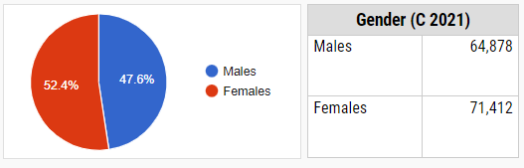

## Figure 3.1 percentage rate of Gender

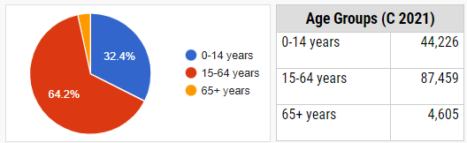

## Figure 3.2: percentage rate of Age Groups

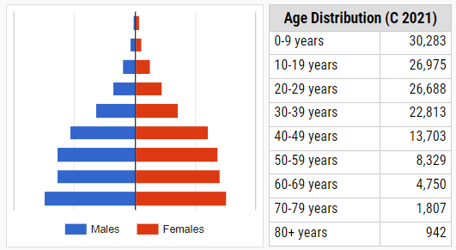

## Figure 3.3: Age Distribution.

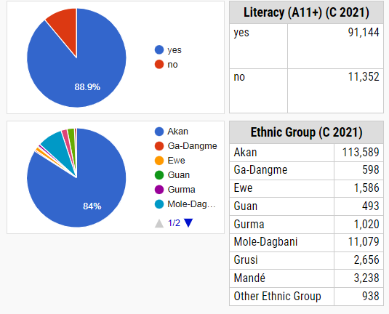

## Figure 3.4: show the Literacy and Ethnic Groups

Due to financial and time constraints, this study used a convenience non-probability sample technique. Convenience sampling is defined as a random selection of sampling units from the population segment that has the most information on the characteristic of interest (Mware, 2017). It is a sampling approach in which the researcher uses his or her own discretion in selecting individuals from the population to participate in the study. It is a non-probability sampling approach in which the items picked for the sample are chosen at the researcher's discretion. Convenience sampling works well in this study because it gets a representative sample while utilising sound judgement, saving time and money. The following Eq 3.1 sampling without replacement is used to get the sample size.

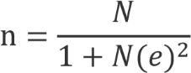**Equation 3.1:**

e = 10%, N = 136,290 and we thus obtain n to be 100 Where:

n is the sample size

N is the population size

E is the margin of error

## **3.4 Data Collection Instrument**

Primary and secondary data gathering strategies are used in this study. Primary data is gathered through sensor data sent to the IoT cloud infrastructure, while secondary data is gathered from distributed questionnaires to the specified sample.

Questionnaires were chosen as the ideal tools for this study since they are a valuable and convenient method of data collection. Due to timing constraints, this was required. Questionnaires also offer respondents confidentiality, and because responses are gathered in a systematic manner, questionnaires provide a more objective approach. A total of 96 household representatives participated in this survey.

In addition to primary data, the research recommends collecting secondary data from prior studies, including much of the data gathered in Chapter 2 of this study.

The Requirements Analysis Questionnaire was used to discover lacking capabilities in current tank monitoring techniques and to help us define new requirements. As a result, the research can better address the research question (i). The System Usability questionnaire, on the other hand, assisted us in achieving the study's developmental and beta testing techniques.

## **3.5 Ethical Consideration**

To verify that ethical standards were followed in this study, the researcher received agreement from the individuals drawn from the selected sample prior to administering the survey. The information and data received from the study were treated with strict secrecy and were only published for the objectives of this research study.

## **3.6 Description of Proposed System**

The System was designed based on the user needs gathered and a thorough examination of the existing tank monitoring systems. These requirements and the analytical results were combined to create a structured system design for the suggested prototype.

The structured system design method was used, with the goal of obtaining a blueprint of the system being created. The research used workflow diagrams, use case diagrams, sequence diagrams, and data flow diagrams at this stage. The hardware components include an Arduino shield, sensors, and a wireless data connection module. The work was carried out on a Windows platform employing the Arduino IDE and the C++ programming language.

## **3.7 System Development/Building**

Systems development is the process of defining, designing, testing, and implementing a new software application or program. It could include the internal development of customized systems, the creation of database systems, or the acquisition of third party developed software.

### **3.7.1 Tools**

The tools or components intend to use to develop the system are as follows;

* Arduino Uno
* Ultrasonic Sensor
* Buzzer
* Liquid Crystal Display
* IC 7805 Voltage Regular
* Relay Module
* Submersible Water Pump
* Battery
* Breadboard
* Connecting wires

## **3.7.1.1 Arduino Uno**

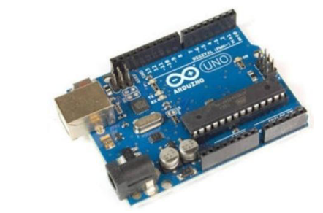

## Figure 3.5 Arduino Uno Board

The ATmega328P-based Arduino Uno is a microcontroller board. It has a 5V operating voltage. It contains 14 digital I/O pins (six of which may be utilized as PWM outputs) and 6 analog inputs. It contains a USB connection, a power connector, an ICSP header, and a reset button, as well as a 16 MHz quartz crystal. It contains all of the components required to support the(Pandey et al. 2022) microcontroller. To get started, just connect it to a computer through USB or power it with an AC-to-DC converter or battery (Pandey et al. 2022).

The name "Uno" means "one" in Italian and was selected to represent the launch of the Arduino Software (IDE) 1.0. The Uno board and Arduino Software (IDE) version 1.0 were the reference versions of Arduino, which have since progressed to later releases. The Uno board is the first of a series of USB Arduino boards and the reference model for the Arduino platform; see the Arduino index of boards for a comprehensive list of current, historical, and obsolete boards (Pandey et al. 2022).

## **3.7.1.2 Ultrasonic Sensor**

An ultrasonic sensor is a gadget that uses sound waves to determine distance. It calculates distance by emitting a sound wave at a specified frequency that sensors can detect.

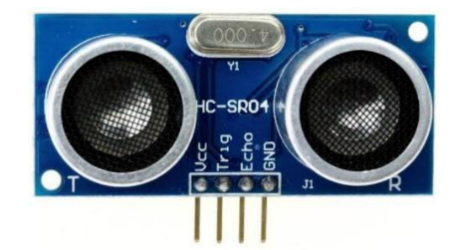

## **Figure 3.6 Ultrasonic Sensor**

Piezoelectric crystals that resonate at a specific frequency and transfer electric power to acoustic power and then, inside the shape of a cone, thoughts from a goal are conveyed back to the transducer. A signal is generated to conduct some type of signaling or manipulating function. A little distance from the sensor is required to provide a delay that allows the "echoes" to be interpreted. The targets might be any reflecting form, including spherical objects. This is a noncontact water level measuring sensor with a measurement range of 2cm-4m. The transmitter sends out an ultrasonic wave, which is reflected back and absorbed by the receiver, where it is converted to an electric wave. The sensor's output is in centimeters or inches. The operating voltage is 5 volts, and the frequency is 40 Hz(Pandey et al. 2022).

## **3.7.1.3 Buzzer**

A buzzer or beeper is an electrical signaling device that is commonly seen in vehicles, domestic appliances such as microwave ovens, and game shows. Buzzers got their name from the rasping noise they made when they were electromechanical devices powered by stepped-down AC line voltage at 50 or 60 cycles. A ring or a beep are two other popular noises used to signify that a button has been pressed(Pandey et al. 2022).

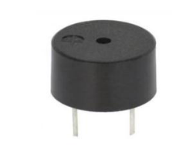

## Figure 3.7 Buzzer

It typically consists of a number of switches or sensors connected to a control unit that determines if and which button was pressed, or if a predetermined time has elapsed, and usually exposes a light on the appropriate button or control panel and sounds a warning in the form of a continuous or intermittent buzzing or beeping sound. Originally, this device was based on an electromechanical system that was similar to an electric bell but lacked the metal gong (which produces the ringing noise). These devices were frequently fastened to a wall or ceiling and used the ceiling or wall as a sounding board. Another implementation with an AC-connected device. The goal was to build a circuit that would convert the alternating current into a loud enough noise to drive a loudspeaker and connect it to an inexpensive 8-ohm speaker. Currently, it is more common to utilize a high-pitched ceramic-based acoustic sounder, such as a Son alert. They were typically connected to "driver" circuits that altered the pitch of the sound or pulsed the sound on and off.

## **3.7.1.4 Liquid Crystal Display**

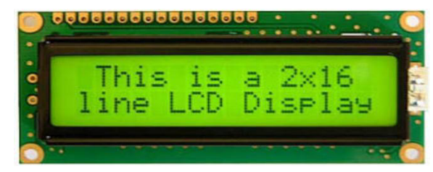

## Figure 3.8 Liquid Crystal Display

LCD (Liquid Crystal Display) screen is an electronic display module and find a wide range of applications. A 16x2 LCD is very basic module and is very commonly used in various devices and circuits. These modules are preferred over seven segments and other multi segment LEDs. The reasons being:

* + - LCDs are economical
    - Ease of programming for characters and graphics.

A 16x2 LCD means it can display 16 characters per line and there are 2 such lines. In this LCD each character is displayed in 5x7 pixel matrix. This LCD has two registers, namely, Command and Data. The command register stores the command instructions given to the LCD. A command is an instruction given to LCD to do a predefined task like initializing it, clearing its screen, setting the cursor position, controlling displayed. The data register stores the data to be displayed on the LCD. The data is the ASCII value of the character to be displayed on the LCD(Pandey et al. 2022).

## **3.7.1.5 IC 7805 VOLTAGE REGULATOR**

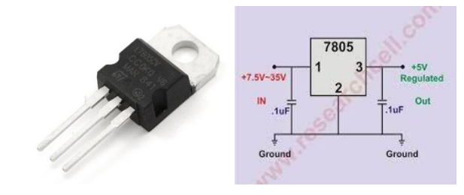

## Figure 3.9 IC 7805 VOLTAGE REGULATOR

This IC 7805 is a three-terminal device with the three pins being INPUT, GROUND, and OUTPUT. The Fig. 3.9 shows the pins on a typical 7805 IC.

**Pin 1 is the INPUT Pin. A positive unregulated voltage is given as input to this pin.**

**Pin 2 is the GROUND Pin. It is common to both Input and Output.**

**Pin 3 is the OUTPUT Pin. The output regulated 5V is taken at this pin of the IC.**

As I have previously talked about regulated power supply as a device that works on DC voltages and it can uphold its output accurately at a fixed voltage all the time even if there is a significant alteration in the DC input voltage. As per the datasheets of 7805 IC, the basic circuit required for 7805 to work as a complete regulator is very simple. In fact, if the input supply is an unregulated DC Voltage, then all you need are two capacitors (even those are not mandatory depending on the implementation).

The above schematic shows all the components required for a 7805 IC to work properly. The 0.22µF Capacitor near the input is required only if the distance between the regulator IC and the power supply filter is high. Also, the 0.1µF Capacitor near the output is optional and if used, it helps in the transient response. In this circuit, VIN is the input voltage to the 7805 IC and the source can be from either a battery of an unregulated DC. VOUT is the output of the 7805 IC, which is a Regulated 5V (Pandey et al. 2022).

## **3.7.1.6 Relay Module**

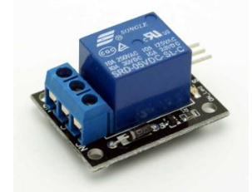

## Figure 3.10 Relay Module

This is a small and easy to use 1 channel relay board that operates on 5V. Use it to control one 240V power appliance lights, fans, etc. directly from microcontrollers or low voltage circuits. The relay can handle a maximum of 7A/240 V AC or 7A/24V DC. Relay has all three connections – Common (COM), Normally Open(NO), Normally Closed(NC) brought out to 3 pin screw terminals which makes it easy to make and remove connections. The board has a power indication (RED) and a relay status (GREEN) LED to ease debugging. The board can accept inputs within a wide range of voltages from 3V to 5V. Power input and relay control signals are brought to 3 pin header pins on the board. Hence, the board can be easily interface with our development boards using our female to female jumper wires.

A relay is an electrically operated device. It has a control system and (also called input circuit or input contactor) and controlled system (also called output circuit or output cont actor). It is frequently used in automatic control circuit. To put it simply, it is an automatic switch to controlling a high-current circuit with a low-current signal.

The advantages of a relay lie in its lower inertia of the moving, stability, long-term reliability and small volume. It is widely adopted in devices of power protection, automation technology, sport, remote control, reconnaissance and communication, as well as in devices of electro-mechanics and power electronics. Generally speaking, a relay contains an induction part which can reflect input variable like current, voltage, power, resistance, frequency, temperature, pressure, speed and light etc. It also contains an actuator module (output) which can energize or de-energize the connection of controlled circuit. There is an intermediary part between input part and output part that is used to coupling and isolate input current, as well as actuate the output. When the rated value of input (voltage, current and temperature etc.) is above the critical value, the controlled output circuit of relay will be energized or de-energized(Pandey et al. 2022).

## **3.7.1.7 Submersible Water Pump**

A submersible pump, also called an electric submersible pump, is a pump that can be fully submerged in water. The motor is hermetically sealed and close-coupled to the body of the pump. A submersible pump pushes water to the surface by converting rotary energy into kinetic energy into pressure energy. This is done by the water being pulled into the pump: first in the intake, where the rotation of the impeller pushes the water through the diffuser. From there, it goes to the surface. The major advantage to a submersible pump is that it never has to be primed, because it is already submerged in the fluid. Submersible pumps are also very efficient because they don’t really have to spend a lot of energy moving water into the pump. Water pressure pushes the water into a submersible pump, thus “saving” a lot of the pump’s energy.

Also, while the pumps themselves aren’t versatile, the selection certainly is. Some submersible pumps can easily handle solids, while some are better for liquids only. Fig. 3.11

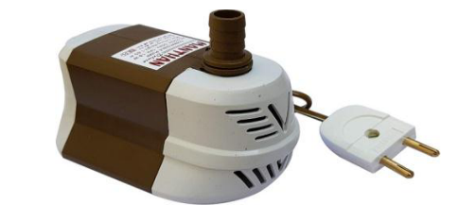

## Figure 3.11 Submersible Water Pump

Submersible pumps are quiet, because they are under water, and cavitation is never an issue, because there is no “spike” in pressure as the water flows through the pump.

There are a few disadvantages with submersible pumps, and two have to do with the seal. The seals can become corroded with time. When that happens, water seeps into the motor, rendering it useless until it is repaired. Also, that seal makes the submersible pump a bit difficult to get into for repairs. The other main disadvantage is that one pump does not fit all uses. Single stage pumps are used for most home and light industrial pumping. This includes aquarium filters, sewage pumping, or sump pumps for drainage. Multiple stage pumps are used for anything underground, such as water wells or oil wells. Also, pumps are made to work with thin liquids like water, or thick ones like sewage. Caution must be used with submersible pumps; they must be fully submerged. The water around a submersible pump actually helps to cool the motor. If it is used out of water, it can overheat(Pandey et al. 2022).

## **3.7.1.8 BATTERY**

A battery source of 12V is used in this paper.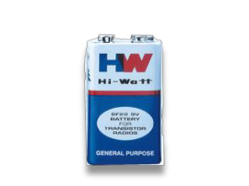

## Figure 3.12 Battery

## **3.7.1.9 BREAD BOARD**

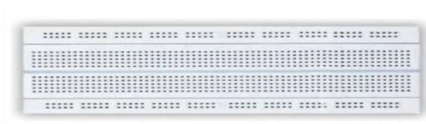

## Figure 3.13 Bread Board

Breadboards usually are plugged in to a standard power supply that either connects to a wall outlet or a battery. Certain holes in the breadboard are connected to positive or negative voltage so that when a circuit is correctly wired and the breadboard is plugged in, current flows through the circuit. Usually, they're used with low levels of voltage and current so that components are safe to touch even while the breadboard is plugged in, but it's a good idea to keep the breadboard unplugged and, if it has a power switch, turned off until a circuit is complete to avoid shocks or damaged components(Pandey et al. 2022).

It's easier and faster to work with breadboards to lay out circuits than it would be to try to wire components without one, so they're useful for quickly testing and prototyping electronics ideas. Breadboards can also be used without soldering, which makes it easy to remove components and reuse them when you're done with an experiment. If you're building a simple electronic paper for home use, you may be able to leave it on the breadboard while it's in use, but a commercial paper would need to be remade on a permanent platform.

## **3.7.2.0 Connecting Wires**

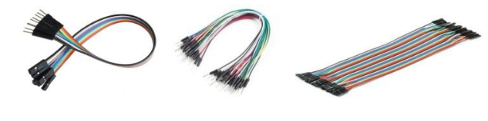

## Figure 3.1.4 Connecting Wires

Connecting wires will be required to connect all the above components with Arduino and breadboard.

### **3.8 Development Process**

Instead of extensive upfront preparation, this study employs the Rapid Application Development (RAD) methodology, a software development approach for iterative development and rapid

****prototyping (Larman, 2004). Because the researcher was looking for speedy findings, rapid application development provided outstanding development procedures with the help of other development methodologies (Abrahamsson et al, 2003). The lack of considerable pre-planning enabled the programme to be created considerably faster and made it easy to adjust requirements, as shown in Figure 3.1.5.

# **Figure 3.1.5: Rapid Application Development**

The rapid application development process begins with the formation of early data models and business process models by adopting structured methodologies during the requirements planning stage. The requirements were then validated through design and prototyping in order to finally develop the data and process models. These steps were iteratively repeated; additional development results in a mix of the business requirements, technical design statements, and testing were utilized to produce the prototyped systems.

## **3.9 The System Design Life Cycle (SDLC)**

After considering numerous methods used in the development of this projects, we settled on  
using the **System Development Life Cycle (SDLC)** to develop our project, precisely **Rapid Application Development (RAD). A**lso following the various phase in terms of developing a system, which includes; Planning, Analysis, Design and System Implementation.

### **3.9.1 Planning Phase**

The planning phase establishes the fundamental process of understanding why a Smart-bin prototype for an in-house waste management system should be built. This phase will also determine how the project team will go about building the system.

The planning phase consists of two main steps:

1. Project Initiation and
2. Project Management

#### **3.9.1.1 Project Initiation:**

During this step, the system’s business value to clients is identified. In other words, how does the tank level detection system add value to users of the application? through questions and answering, we identified the core values our clients want the system to impact in their homes and industries.

They include,

1. Water tank are beneficial to the individual. Water tank helps individuals and industries to store safe and clean water for use.
2. By using a light compaction technique, you may increase the tank's capacity and store more water in the tank.
3. The system has been designed to be reduced water waste electricity consumption by controlling the status of the tank to avoid water split.

#### **3.9.1.2 Project Management:**

Our team prepared a work plan to manage the project during this stage. The strategy comprises the following:

1. The system's user demand, which outlines what the users anticipate from the system, to be able to, you'll need a system.
2. The system requirement, which outlines the system's characteristics and behavior,
3. Assigning members to different project phases, which may include members required for the project's documentation and the individuals assigned to it. Create the system and put it in place.

## **3.9.2 Analysis Phase**

The analysis phase will answer the questions of who will use the system, what the system  
will do, and where and when it will be used. During this phase the project team investigates  
any current system(s), identifies improvement opportunities, and develops a concept for the  
new system.

The research also used a multi-technique methodology to gather needs from potential clients. The requirements elicitation procedure was accomplished through the use of questionnaires and the creation of prototypes. This combination allowed the researcher to obtain a full picture from the various client and stakeholder groups.

### **3.9.2.1 Questionnaires**

The requirements elicitation questionnaires were much more informal, and they were an excellent tool for gathering requirements from stakeholders in remote locations or those with only minor input into the overall requirements. The surveys were critical since the researcher

received information from hundreds of individuals, making it easier to reach the big masses and provide quick responses via email, Facebook, WhatsApp, Skype, and other social platforms.

### **3.9.2.2 Prototyping**

Prototyping is a relatively new approach to requirement collection. The research employed this technique to gather basic requirements, which were then used to develop an initial version of the solution-the prototype(Mware, 2017). This was later displayed to the customer, who provided further specifications. The programme would then run through the application updates and loop

back around to the client. This iterative procedure was repeated until the product reached a critical mass of business requirements.

This phase is also based on **three key steps**. These include;

***Analysis strategy***: This is created to direct the activities of the project team. This involves review of the existing system. Questionnaires were randomly distributed to households in our research area to see how they monitor and regulate water waste. According to research data, a proportion of households used a manual procedure for monitoring and regulating water tanks, which consisted just of a manual time set or individual monitoring the tank until is full.

***Requirements gathering***: Based on the information gathered from the various households, they were asked whether they would like an automation application that would help control water tank level by identifying fill-level and informing the user through LEDs for further actions.

***System proposal***: The proposal is presented to the group officially whether the project should continue or otherwise.

## **3.9.3 Design Phase**

This phase explains in detail the specifications, features, and activities that will be required to address the functional requirements of the proposed system. End users discuss and establish their unique business information needs for the proposed system at this stage. During this phase, they

will consider the system's basic components (hardware and/or software), structure (networking capabilities), processing, and processes to achieve its goals.

## **3.9.3.1 DATA FLOW DIAGRAM**

A Data Flow Diagram (DFD) is a graphical representation of the “flow” of data through an information system. DFD can also be used for the visualization of data processing. Automatic water level indicator and controller system uses two sensors at two levels of the tank, i.e. one at the higher level of the tank and the other at the lower level of the tank is shown in Figure 3.1.6

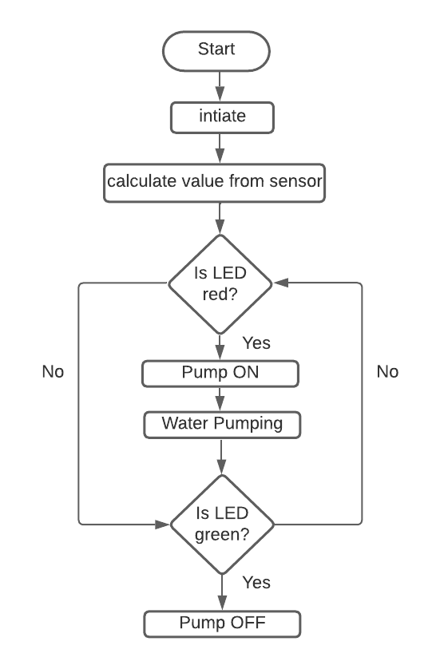

## Figure 3.1.6 Flow chart diagram for proposed system

If measured level is below the threshold level of 2cm then the tank becomes empty then LED display indicates “1 or red”, water pump will automatically be switched ON. Henceforth, When the water reaches a particular level of the LED display indicates “6 or green”, which will automatically pump OFF and which will be indicating the tank is full.

## **3.9.3.2 BLOCK DIAGRAM**

As shown in block diagram, ultrasonic sensor module’s “trigger” and “echo” pins are directly connected to pin 12 and 13 of Arduino. “GND” and “VCC” pins are connected to GND of bread-board and 5V of Arduino. A LED display is connected with Arduino. Out of 10, the 8 pins i.e. a, b, c, d, e, f, g and DP segment (decimal Point) are connected to digital pins i.e. 9, 6, 4, 3, 2, 8, 7 and 5 of Arduino. The pin 3 and 8 are internally connected to form a common pin. This pin should be connected to GND (common cathode) or 5V (common anode) depending upon the type of the display. Relay is also connected to pin of Arduino through ULN2003 for turning ON or turning OFF the water motor pump.

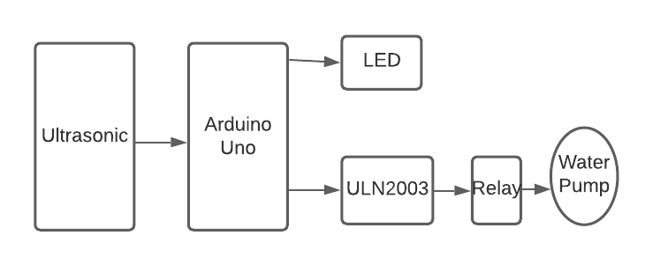

## Figure 3.1.7 Block Diagram

When the circuit is switched ON, the ultrasonic sensor transmits the generated sound signal to the bottom of the water tank which is the target and whose water level is to be measured. The signal after touching the base of the tank is reflected back and is received by the receiver of the ultrasonic sensor. The time taken through the entire journey of the transmitted signal is recorded. The output obtained is the required distance

## **3.9.3.3 Use Case Modeling**

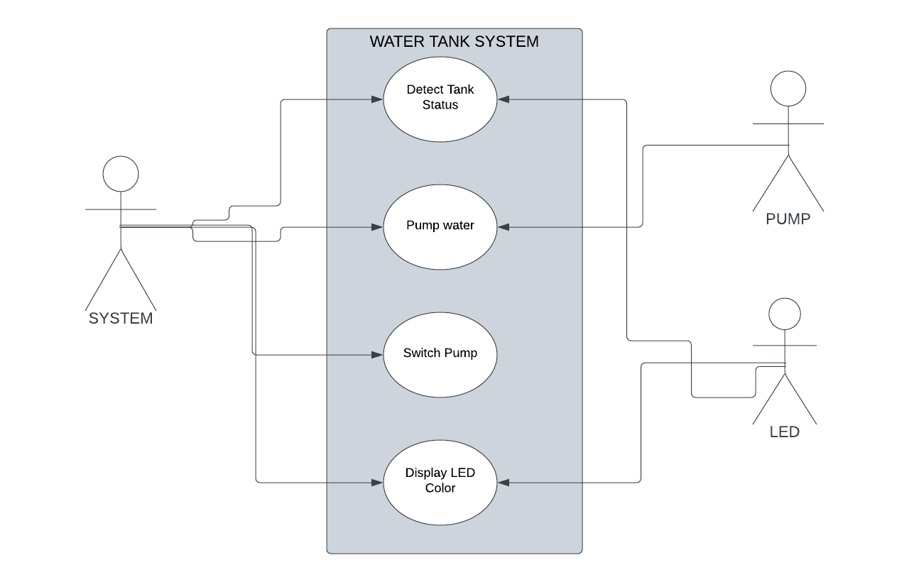Figure 3.10 shows a water tank system use case diagram, which serves as a visual depiction of the system's many responsibilities and how they interact with its various functionalities. It depicts the actions carried out by system users, or the functional needs from the user's perspective.

## Figure 3.1.8 Use Case Diagram

## **3.9.3.4 Use Case Modeling**

Interaction diagrams called sequence diagrams show the actions that must be taken to complete a job. They show how things interact when operating within a cooperative system. Sequence diagrams, which place a strong focus on time, can graphically express the sequence of an interaction by utilising the vertical axis of the diagram to represent time and the messages that are conveyed and when.

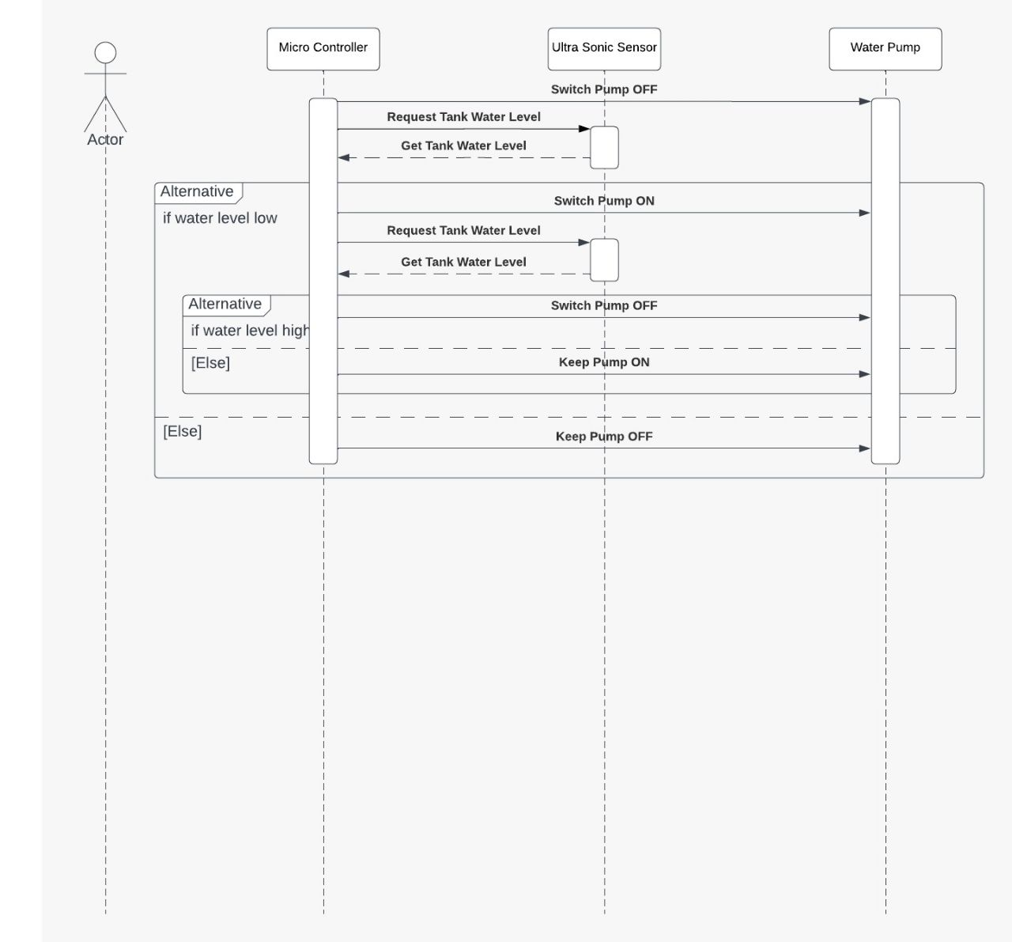

## Figure 3.1.9 Sequence Diagram

1. The user requests water from the Automatic Water Tank Filling System.
2. The system checks the water level in the tank using an Arduino-based sensor.
3. If the water level is below a certain threshold, the system pump turns on to allow water to flow into the tank.
4. The system waits for the tank to fill to a certain level.
5. Once the tank is filled to the desired level, the system closes or switch off pump to avoid the water flow into the tank.
6. The system notifies the user that the tank has been filled.

## **3.9.4 Implementation Phase**

The implementation and evaluation of the water tank system are described in this chapter. The development environment, tools, development platform, and tiers of system users are all considered in terms of implementation.

### **3.9.4 Development Environment**

A suitable development environment is created to verify that the implementation process functions well. The software and hardware requirements for the development process are as follows:

#### **3.9.4.1 Hardware and Software Requirement**

Table 3.1 describes the hardware requirement and software requirement of the water tank system.

# **Table 3.1 Hardware Requirement**

|  |  |
| --- | --- |
| **Hardware** | **Description** |
| **Arduino uno Board** | **Arduino Uno** microcontroller board (ATmega328). It has 14 digital input/output pins (of which 6 can be used as PWM outputs), 6 analog inputs, a 16 MHz crystal oscillator, a USB connection, a power jack, an ICSP header, and a reset button. |
| **Buzzer** | A buzzer or beeper is an electrical signaling device that is commonly seen in vehicles, domestic appliances such as microwave ovens, and game shows |
| **Liquid Crystal Dispaly** | LCD (Liquid Crystal Display) screen is an electronic display module and find a wide range of applications. A 16x2 LCD is very basic module and is very commonly used in various devices and circuits |
| **Submersible pump** | A submersible pump, also called an electric submersible pump, is a pump that can be fully submerged in water. The motor is hermetically sealed and close-coupled to the body of the pump. |
| **A Solder less PCB**  **Breadboard** | Model: MB-102  Dimension: 165mm x 55mm x 10mm, Tie Points: 830 Tie Points consists of: 630 Tie-Point Terminal Strip, 200 Tie-Point Distribution Strips,  Matrix: 126 separates 5-point terminals, plus 4 horizontal bus lines (Power Lines) of 50 test points each, Wire size: Suitable for 29-20 AWG wires |
| **Jumper Wires** | 20cm, wire cable connectors from dupont. Male to Female, Female to Female and Male to Male terminated. |
| [**HC-SR04 ULTRASONIC**](https://store.nerokas.co.ke/index.php?route=product/product&product_id=105)  [**SENSOR**](https://store.nerokas.co.ke/index.php?route=product/product&product_id=105) | The HC-SR04 ultrasonic sensor uses sonar to determine distance to an object like bats or dolphins do. It offers excellent range accuracy and stable readings **Features:**  Power Supply :5V DC, Quiescent Current: <2mA, Effectual Angle: <15°,  Ranging Distance: 2cm – 500 cm/1" - 16ft, Resolution: 0.3 cm |
| **Relay Module** | This is a small and easy to use 1 channel relay board that operates on 5V. Use it to control one 240V power appliance lights, fans, etc |
| **Arduino Software (IDE)** | Arduino is a cross-platform Integrated Development Environment (IDE). It collaborates with an Arduino controller to allow for the writing, compiling, and uploading of code to the board. |

# **3.9 Summary**

It focuses on the study design, the targeted population, sample size, sampling methodologies, data kinds, data gathering techniques, data analysis, and test design. Research Design According to Yin, research design is the logical process that relates empirical data to a study's original research questions and, eventually, to its findings.

The information and data received from the study were treated with strict secrecy and were only published for the objectives of this research study. Description of Proposed System, the Water Tank System was designed based on the user needs gathered and a thorough examination of the existing monitoring systems.

This comprises the pins needed for UART communication with a microcontroller. Development Process Instead of extensive upfront preparation, this study employs the Rapid Application Development methodology, a software development approach for iterative development and rapid prototyping.

The lack of considerable pre-planning enabled the programme to be created considerably faster and made it easy to adjust requirements, as shown in Figure 3.1.5. Figure 3.1.5: Rapid Application Development The rapid application development process begins with the formation of early data models and business process models by adopting structured methodologies during the requirements planning stage.

These steps were iteratively repeated; additional development results in a mix of the business requirements, technical design statements, and testing were utilized to produce the prototyped systems. The System Design Life Cycle After considering numerous methods used in the development of this projects, we settled on using the System Development Life Cycle to develop our project, precisely Rapid Application Development.

Also following the various phase in terms of developing a system, which includes; Planning, Analysis, Design and System Implementation. Planning Phase The planning phase establishes the fundamental process of understanding why a Smart-bin prototype for an in-house waste management system should be built.

Create the system and put it in place. The analysis phase will answer the questions of who will use the system, what the system will do, and where and when it will be used.

System proposal: The proposal is presented to the group officially whether the project should continue or otherwise.3.8.3 Design Phase This phase explains in detail the specifications, features, and activities that will be required to address the functional requirements of the proposed system.

The development environment, tools, development platform, and tiers of system users are all considered in terms of implementation. Development Environment A suitable development environment is created to verify that the implementation process functions well.

# **References**

Bhujade, C. P., Bisen, H. D., Hatwar, G. V., Bharati, A. K., & Sawarkar, N. FLOW RATE AND FLUID LEVEL MEASUREMENT AND AUTOMATIC CONTROLLING UNIT.

Bitella, G., Rossi, R., Bochicchio, R., Perniola, M., & Amato, M. (2014). A novel low-cost open-hardware platform for monitoring soil water content and multiple soil-air-vegetation parameters. *Sensors*, *14*(10), 19639-19659.

D’Ausilio, A. (2012). Arduino: A low-cost multipurpose lab equipment. *Behavior research methods*, *44*(2), 305-313.

Devika, S. V., Khamuruddeen, S., Khamurunnisa, S., Thota, J., & Shaik, K. (2014). Arduino based automatic plant watering system. *International Journal of Advanced Research in Computer Science and Software Engineering*, *4*(10), 449-456.

Getu, B. N., & Attia, H. A. (2016, December). Automatic water level sensor and controller system. In *2016 5th International Conference on Electronic Devices, Systems and Applications (ICEDSA)* (pp. 1-4). IEEE.

Kumar, K. S., Mukesh, G., & Deepti, K. (2015). Microcontroller based Automatic Water level Control System. *International Refereed Journal of Motorering And Science (Irjes) Volume*, *4*.

Layton Jr, E. T. (1974). Technology as knowledge. *Technology and culture*, 31-41.

Maoulidi, M. (2010). A water and sanitation need assessment for Kumasi, Ghana.

Mashilkar, B., Khaire, P., & Dalvi, G. (2015). Automated bottle filling system. *International Research Journal of Engineering and Technology (IRJET)*, *2*(07), 771-776.

Nallani, S., & Hency, V. B. (2015). Low power cost effective automatic irrigation system. *Indian Journal of Science and Technology*, *8*(23), 1.

Pandey, Anikka, Gargi Andhale, Anirudha Sonawane, Akshara Amrutkar, and Tejaswini Andhare. 2022. “Automatic Water Level Indicator and Controller.” *International Journal for Research in Applied Science and Engineering Technology* 10(2):1043–47. doi: 10.22214/ijraset.2022.40435.

Prima, E. C., Munifah, S. S., Salam R., Aziz, M. H., & Survani, A. T. (2017). Automatic water tank filling system controlled using ArduinoTM based sensor for home application. Procedia engineering, 170, 373-377.

Pudasaini, S., Pathak, A., Dhakal, S., & Paudel, M. (2014). Automatic water level controller with short messaging service (SMS) notification. *International Journal of Scientific and Research Publications*, *4*(9), 1-4.

Santra, M., Biswas, S., Bandhapadhyay, S., & Palit, K. (2017). Smart wireless water level monitoring & pump controlling system. *International Journal of Advances in Scientific Research and Engineering (IJASRE)*, *3*(4).

Sharma, S., Gupta, S., Gupta, S., & Kotwal, S. B. (2018, June). Iot based innovative dual level control system with fault tolerance & fail-safe capability. In *2018 Second International Conference on Intelligent Computing and Control Systems (ICICCS)* (pp. 307-312). IEEE.

Baldeon-Perez, C., Meneses-Claudio, B., & Delgado, A. (2021). Water level monitoring and control system in elevated tanks to prevent water leaks. *International Journal of Advanced Computer Science and Applications*, *12*(2).

Bagga, D., Gujral, R., & Mishra, A. (2021, May). Real-time Water Level Monitoring Using IOT. In *Proceedings of the International Conference on Innovative Computing & Communication (ICICC)*.

Pall, S. K., Hasan, M., Barai, S., Rahman, M., & Hasan, M. (2022). *Fabrication of Liquid Tank Automation System* (Doctoral dissertation, Sonargoan University).

Abrahamsson, P., Warsta, J., Siponen, M. T., & Ronkainen, J. (2003). New directions on agile methods: {A} comparative analysis. *25th Int. Conference on Software*

Hevner, A. R., March, S. T., Park, J., & Ram, S. (2004). Design Science in Information Systems Research. *MIS Quarterly*, *28*(1), 75–105. <http://doi.org/10.2307/25148625>

Cobb, P., Confrey, J., DiSessa, A., Lehrer, R., & Schauble, L. (2003). Design Experiments in Educational Research. *Educational Researcher*, *32*(1), 9–13. http://doi.org/10.3102/0013189X032001009

Ghana Statistical Service (2021, June 27). The Population Development of Suame Municipal. <https://www.citypopulation.de/en/ghana/admin/ashanti/0641__suame_municipal/>

Abrahamsson, P., Warsta, J., Siponen, M. T., & Ronkainen, J. (2003). New directions on agile methods: {A} comparative analysis. *25th Int. Conference on Software*

Larman, C. (2004). *Agile and Iterative Development: A Manager’s Guide*. *Communication*. <http://doi.org/10.1016/j.amjmed.2009.12.017>

Mware, E. M. (2017). *A Smart-bin management prototype for waste A Smart-Bin Prototype for In-House Waste Management*. 22–47.